[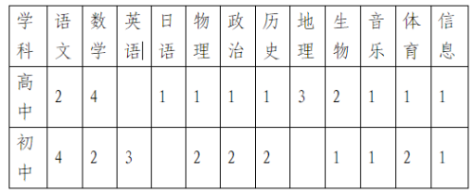](http://www.yangxin.gov.cn/picture/0/b4951ab9e72b42d68772d1645a3a990d.png)